**DATA ANALYTICS ASSIGNMENT - 2**

Allamudi.Yamini

4th B.Tech (CSE)

VNITSW

20NN1A0562

# DONUT CHART:

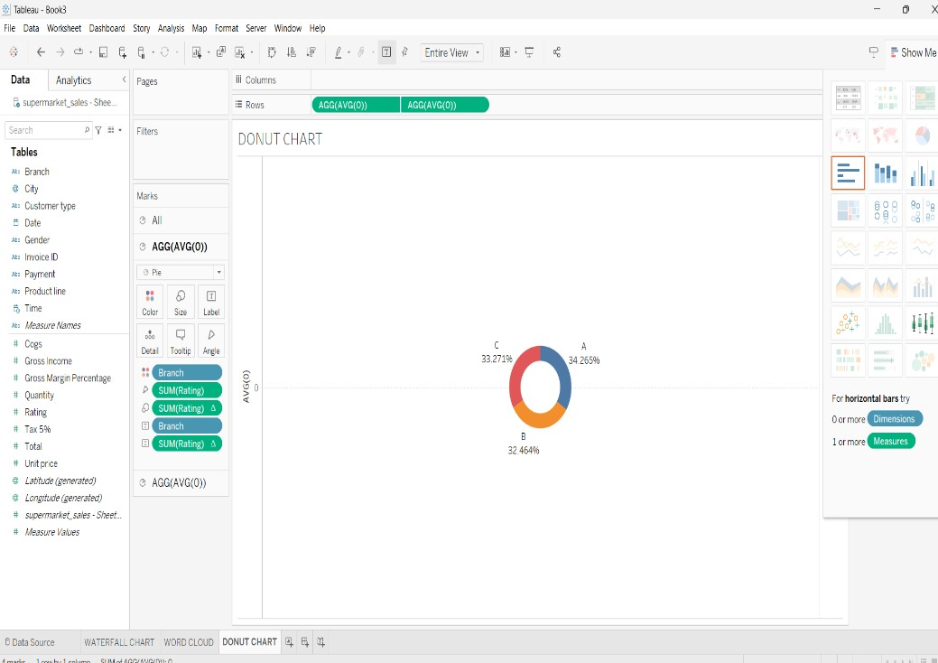

# AREA CHART:

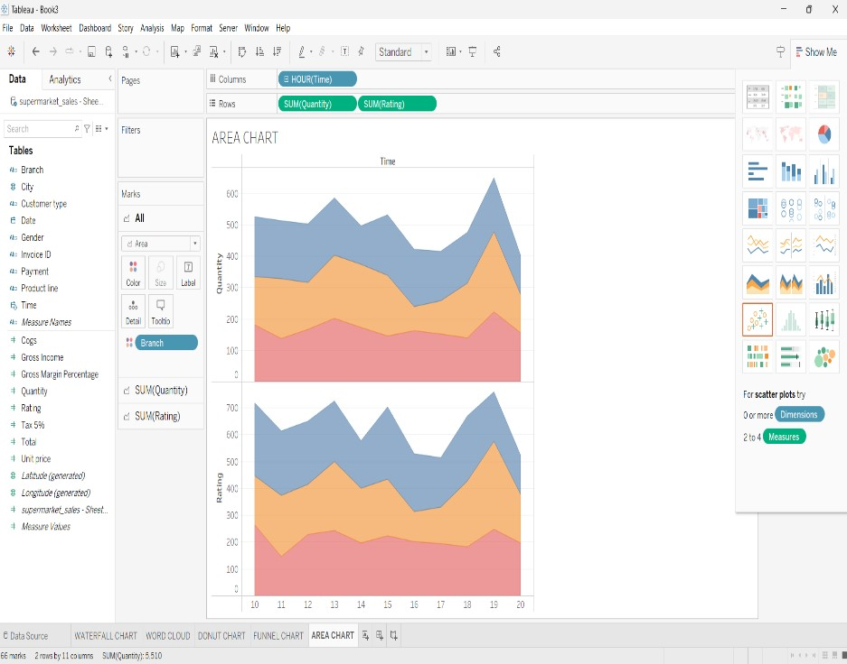

# TEXT TABLE:

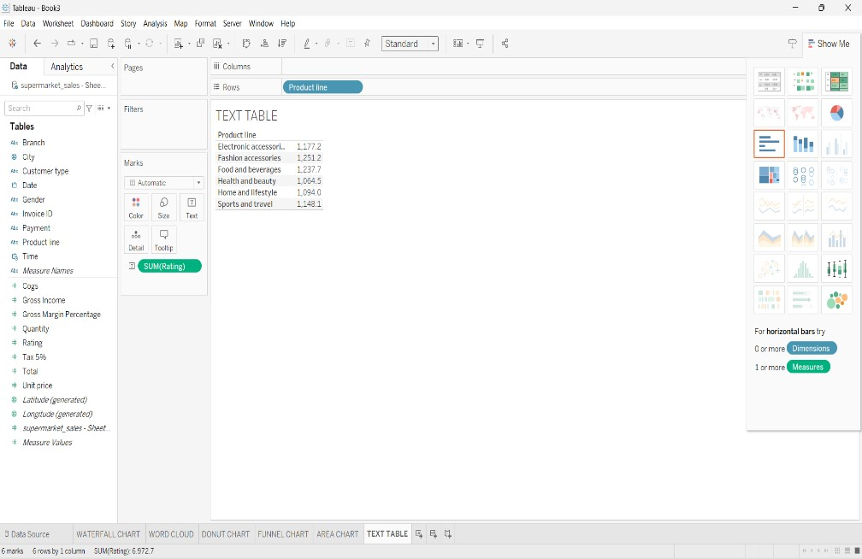

# HIGHLIGHTED TABLE:

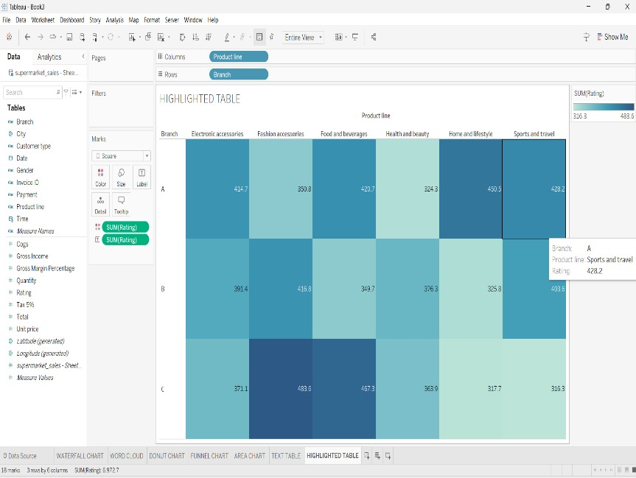

# WORD CLOUD:

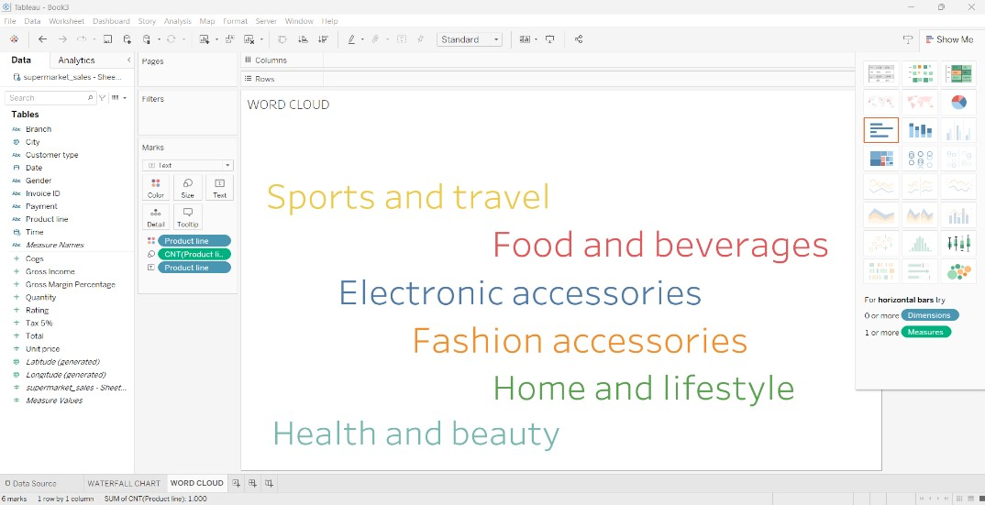

# FUNNEL CHART:

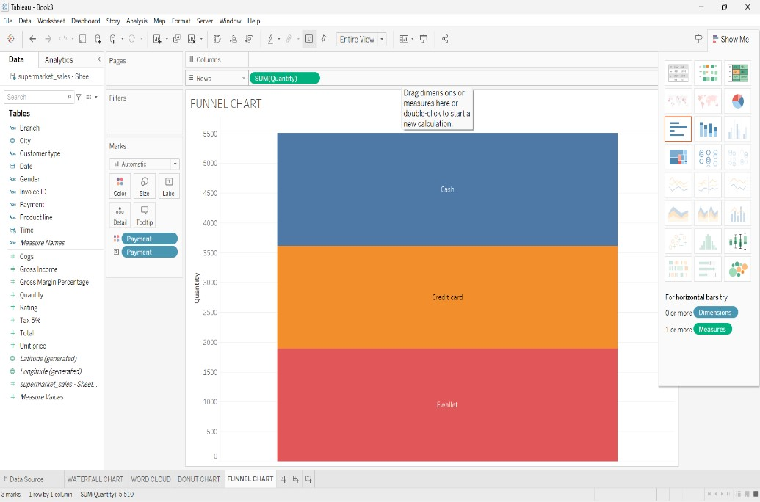

# WATERFALL CHART:

